Evaluating Devices for Our Classroom

Device | ASUS Transformer Pad  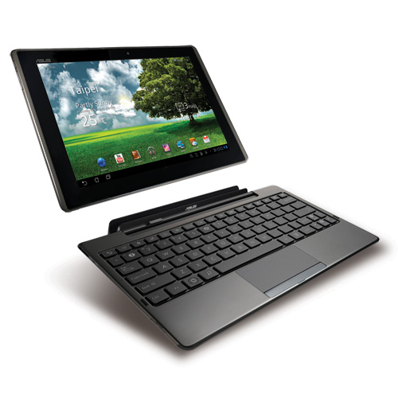 | Acer C720 Chromebook  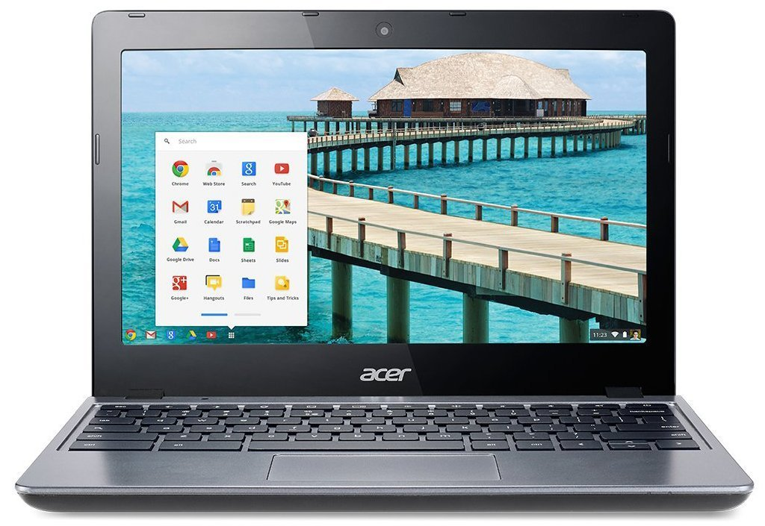 | Acer C720P Chromebook  Touchscreen  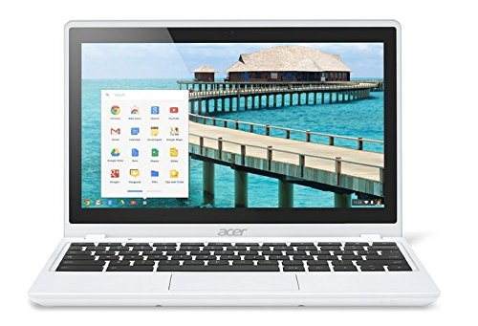 | Apple® - iPad Air 2 Wi-Fi 16GB  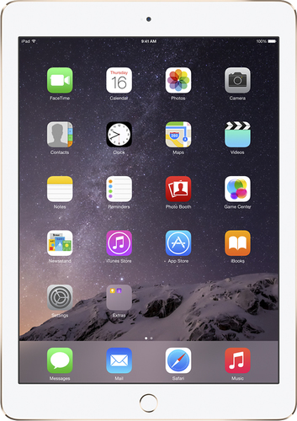 | Apple® - iPad mini 3 Wi-Fi 16GB  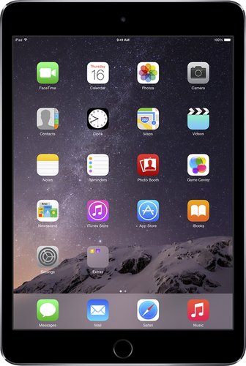
Cost | $239.99 (Amazon)  $215.28 (CDW)  BB - n/a | $239.97 (Amazon)  $247.49 (CDW)  $231.82 (Best Buy) | $250.00 (Amazon)  Only 4 GB on CDW and BB | $454.98 (Amazon)  CDW - n/a  $499.99 (BB) | $329.00 (Amazon)  CDW - n/a  $399.99 (BB)
Operating System  Apps and Programs | Google Play Store - Android Apps | Chrome Web Store | Chrome Web Store | Apple App Store | Apple App Store
Size/Screen

Using Google Classroom
Taking pictures and videos
Browsing the Internet
Creating a Google Doc
Creating a Video
Creating a Presentation

